#6 - Proxy Set-up For Approvers

Introduction
Some words of caution. The proxy set-up is not limited to just one area of self-service such as Web Time Entry; it is system wide which means the proxy can also approve other areas of self-service such as requisitions in Finance.
Accessing the Proxy Set-up
After accessing PAWS, click on the Employee tab, which will bring up the employee menu page. Click on Hourly Time sheet and Salaried Leave Reporting. Next click on Hourly Employee Time Sheet. Next click on Proxy Set Up, which will bring up the Proxy Set Up screen.
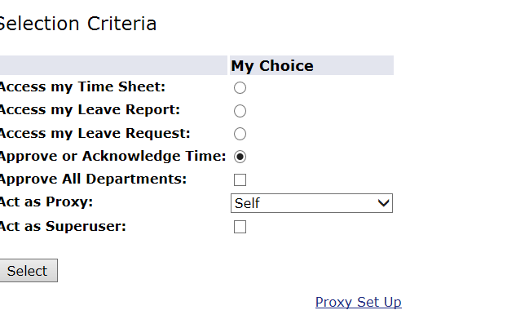

On the Proxy Set Up screen you will click on the down arrow next to the Name field unless your proxy happens to be first on the list. Once you have selected your Proxy, check the box underneath Add Remove, and then click on Save.
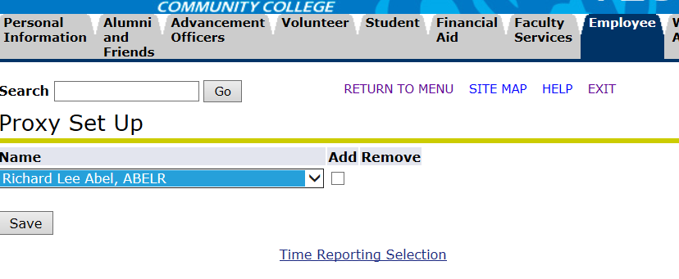
To change your Proxy, you will unclick on the box underneath Add Remove and then click on Save. You will then need to designate a new Proxy

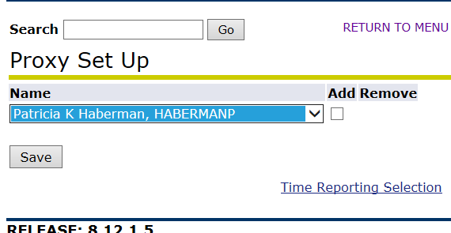
Even though your Proxy will only be standing in occasionally, when this occurs they are performing a very important function on your behalf so you will want to keep your Proxy up-to-date.

