#5 – Approvers Information

Self-service Web Time Entry is a web-based time entry system designed to improve accuracy and eliminate loss or delays in paper processing of physical time sheets. The Web Time Entry system will allow hourly employees to log into a secure website and enter their hours worked and leave taken online from any computer with access to the Internet. Their time is then approved online by you and sent electronically to Payroll for processing.
In order to be paid each month, it is critical that time sheets be submitted and approved by the appropriate payroll deadlines noted in the hourly employee pay calendar. You are responsible for working with your employee to be certain their time sheet is submitted by the appropriate deadline. Without a time sheet, your hourly employee will not be paid.

Some words of caution. Because of functionality problems, do not click on the back browser nor double click on any of the fields while using Web Time Entry.

Accessing Time sheet
After accessing PAWS, click on the Employee tab, which will bring up the employee menu page. Click on Hourly Time sheet and Salaried Leave Reporting. Next click on Hourly Employee Time Sheet. Under Selection Criteria, if you have more than one department to approve you may select both Approve or Acknowledge Time and Approve All Departments, before clicking on Select.
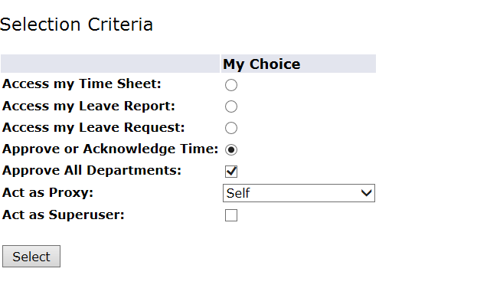


Change Selection: If you have more than one department to approve, and you did not select Approve All Departments, you can click on this button and it will take you back to the Selection page. You will need to select the department for which you wish to approve time by selecting one of the radial buttons under the My Choice column. You will then need to select the appropriate pay period for which you are approving time. If the correct pay period is not displayed, click on the down arrow to select a different pay period. Next click on Select.

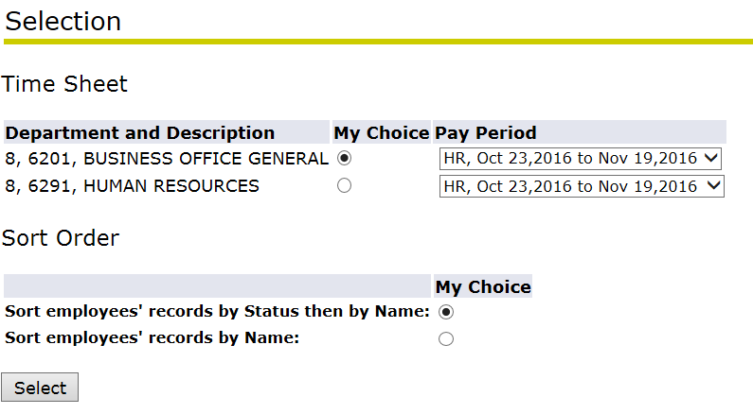
Time Sheet Statuses:
A new summary page will appear. The summary page will display the status of time sheets in the department that was selected. These examples show, the different statuses the time sheets may be at.
Employee has not stared their time sheet. Approver (supervisor) will not see time sheet until at least one time sheet in the department has been started.
If the employees whose time sheet status is Not Started did not work during the pay period, then there is nothing else that needs to be done. Do not ask them to submit a time sheet with zero hours.

Employee has started their time sheet, but has not yet submitted it for approval. Prior to the payroll deadline, you will need to contact any employee’s with a time sheet status of In Progress. They will need to submit their time sheet to you for review and approval before the payroll deadline.

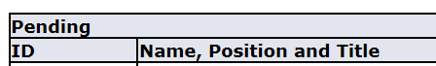
Employee has submitted their time sheet for approval. To review the time sheet that is pending click on the employee’s name. This brings up another page where you will be able to review all of the time the employee has entered on his or her time sheet. Use the scroll bar at the bottom of the page to review the entire pay period.

If the time sheet needs to be corrected, click on Return for Correction. The time sheet will be sent back to the employee electronically. There is no notification that this has occurred, so you will need to notify the employee either verbally or by e-mail and keep in mind the payroll submission deadline.
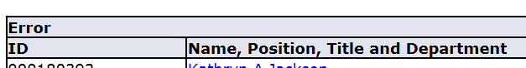
This means your employee’s time sheet is in error status. Please contact the Office of Human Resources for assistance.
If the time sheet is accurate, clicking on Approve, will approve the employee’s time sheet and send it electronically to payroll for processing.
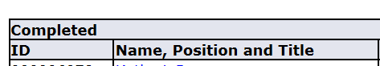

The employee’s time sheet status will go to Complete after payroll has ran the electronic processes that brings employees time into the payroll for processing.

How to Approve Time Sheets
Previous Menu: Click on this button to go back one screen.
Approve: Before clicking on this button to approve the time sheet, the Approver must verify that the time sheet is correct.
Return for Correction: Click on this button if the time sheet needs to be corrected. The time sheet will be sent back to the employee electronically. There is no notification that this has occurred, so you will need to notify the employee either verbally or by e-mail and keep in mind the payroll submission deadline.
Change Record/Change Time Record: This enables the Approver to change the employee’s time record. Whenever possible, the time sheet should be sent back to the employee for correction. Under extenuating circumstances, where this is not possible, the Approver should go ahead and make corrections to the employee’s time sheet and then have the employee send an e-mail acknowledgement to Human Resources acknowledging the change(s) made to their time sheet was correct.
Delete: If an employee sends through a time sheet with zero hours, do not approve it. Click on this button and delete the time sheet.
Add Comment: Prior to approving, this enables the Approver to add a comment to the employee’s time sheet.
Next: This enables the Approver to review the next time sheet in the department.

Select All, Approve or FYI: After reviewing all of your time sheets, you can click on this button and it will place check marks underneath the Approve or FYI column for all time sheets with a status of Pending.
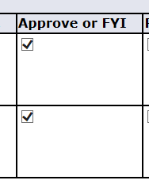
Save: Click on Save to finalize the approval process.
To approve an individual employee’s time sheet:
After reviewing time sheet for accuracy click on Approve. This will approve the employee’s time sheet and send it electronically to payroll for processing.

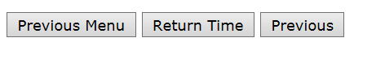
Return Time: If time has been approved but the payroll process has not been executed, click on this button to return time. Time sheet can then be returned for correction.

Log Out
To exit PAWS, click the Exit button in the upper right hand corner of the screen.

More Information
For more information, please contact the Office of Human Resources.

