#4 - How Do I Check The Status of My Time Sheet?

Checking Approval Status
You should check to be certain your supervisor or their designated proxy has approved your time sheet before the payroll deadline. To check the status of your time sheet log into PAWS then click on the Employee tab, this will bring up the employee menu page. Click on Hourly Time sheet and Salaried Leave Reporting. Next click on Hourly Employee Time Sheet. The status appears underneath the Pay Period and Status column. In this example, the status is “Pending” which means the employee has submitted their time sheet and it is awaiting approval by their supervisor or their designated proxy.
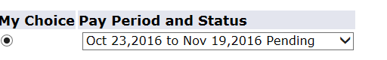
After the employee’s supervisor or their designated proxy has approved their time sheet, the status will go from pending to approved.

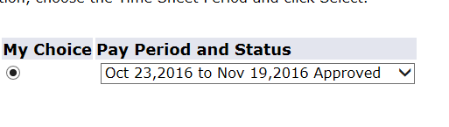
For additional information on time sheet statuses, please refer to the Web Time Entry FAQ’s document posted on the College’s web site.

