#3 - How Do I Submit My Time Sheet for Approval?

Submitting Time sheet for Approval
Access your time sheet by clicking on the Employee tab, this will bring up the employee menu page. Click on Hourly Time sheet and Salaried Leave Reporting. Click on Hourly Employee Time Sheet. Next select the time sheet you wish to submit for approval and then click on Time Sheet.
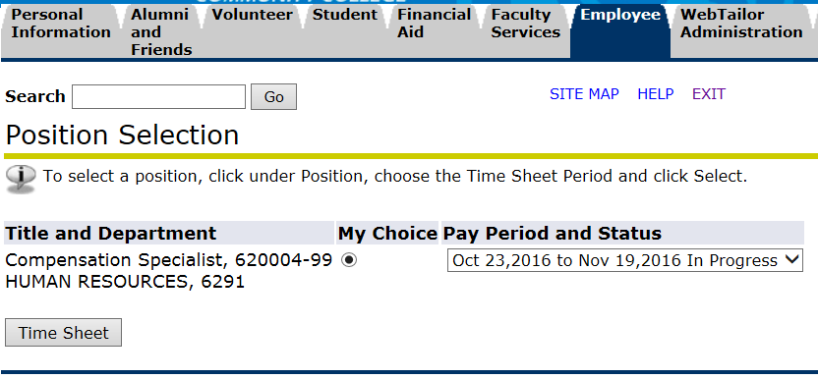
Prior to submitting your time sheet for approval, review it for accuracy by clicking on the Preview button at the bottom of the screen. Use the scroll bar to review the hours or leave entered for each day in the entire pay period.

After you have entered all of your hours for the entire pay period, and you are ready to submit your time sheet to your supervisor for approval, click on Submit for Approval.
The certification page will appear. By re-entering your PIN as your electronic signature, you are certifying the hours recorded on your time sheet are an accurate record of the hours you worked during the pay period. Re-enter your PAWS PIN and then click Submit. Your time sheet has been sent electronically to your supervisor for approval and the status has changed from in In Progress to Pending.

