#2 - Employees: Other Functionality found on the Time sheet Screen & Time Sheet History
Position Selection: Returns you to the Position Selection screen.
Comments: Comments to your supervisor may be added to your time sheet prior to submitting for approval. Comments entered through Web Time Entry will only be seen by your supervisor. If you need to communicate with payroll personnel in the Office of Human Resources, please contact them directly.
Preview: Will display the entire pay period and will show you the hours or leave entered for each day.
Submit for Approval: Use to submit your time sheet at the end of a pay period to your supervisor or their designated proxy for approval. You will need to enter your PIN: and then select submit to complete this process.
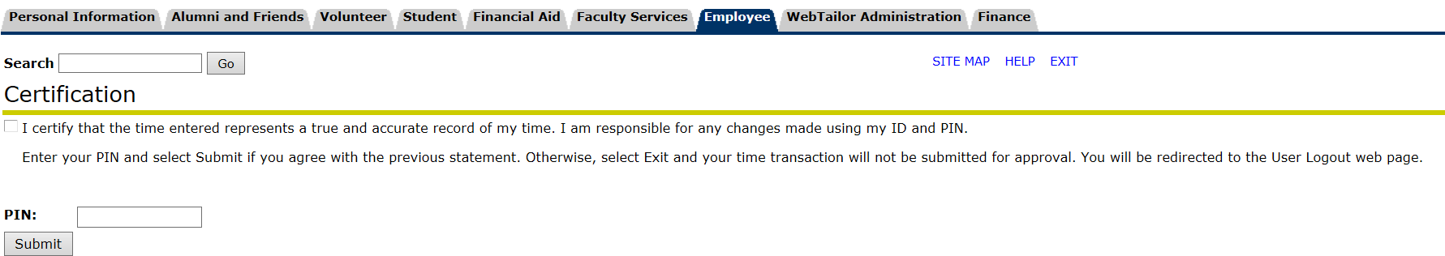
Return Time: After time sheet has been submitted for approval, but before approver has approved time sheet, you may use this button to return your time, allowing you to make needed corrections. After corrections are made, you MUST again select “Submit for Approval”.

Restart: If the time sheet has not been submitted for approval, this button will clear out all hours previously entered and saved for the given pay period and allow you to start over from the beginning.

Previous/Next: Each pay period is either a 4-week or 5-week period but not all of the days can fit on the width of one screen. Click on Previous or Next to toggle between each week.
Account Distribution: This if for accounting purposes only and will not affect your hours or pay.
Time Sheet History: Time sheets will remain viewable online for XXXXXXX. However, if you want to go ahead and print a hard copy for your records, with the image you want to print showing on your screen, select “File”, “Page Set-up” and then change the orientation to Landscape. Then go back to “File” and click on Print. To print the next week in the pay period, click on Next at the bottom of the screen and then repeat this process.
More Information
For more information, please contact the Office of Human Resources.

