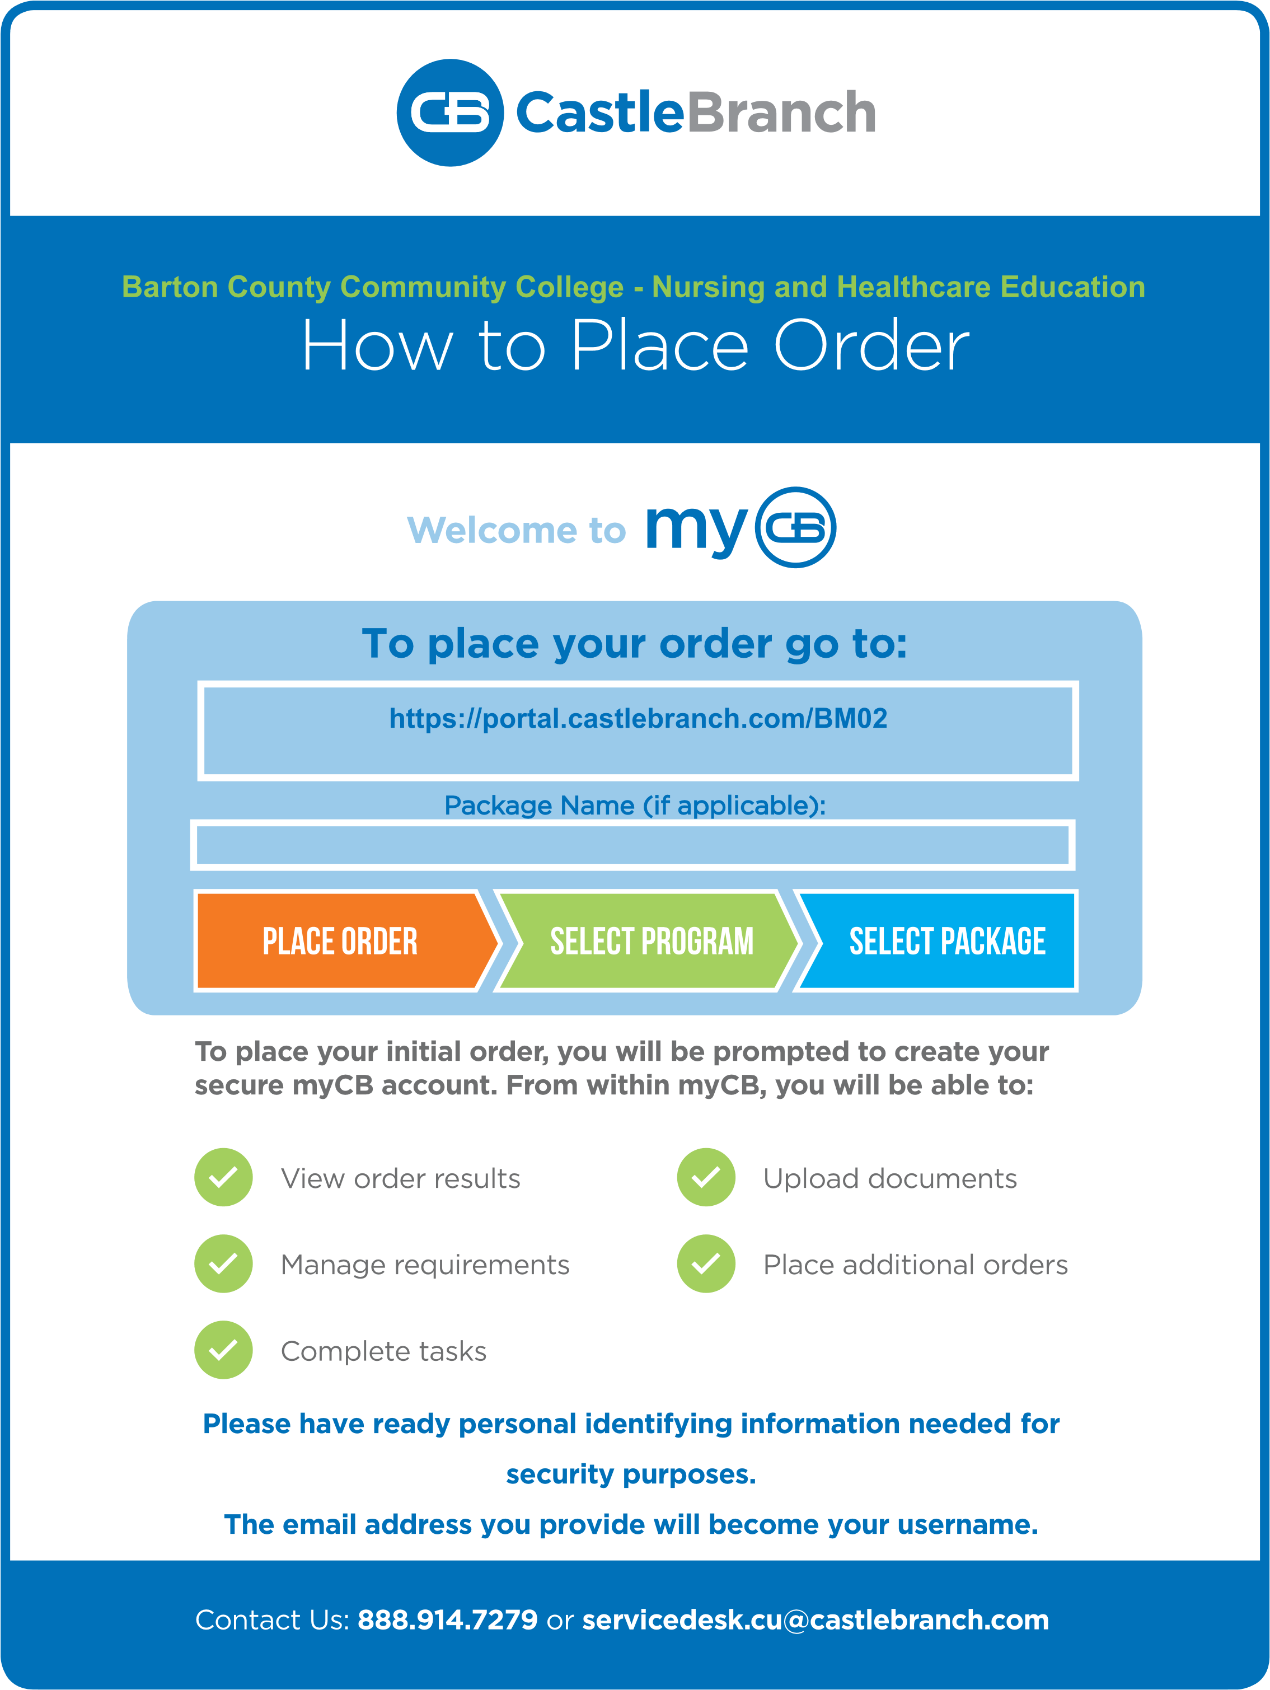 T:\BartonBrand\ProgramLogos\MLT\Web\Blue\mltplblue200.png

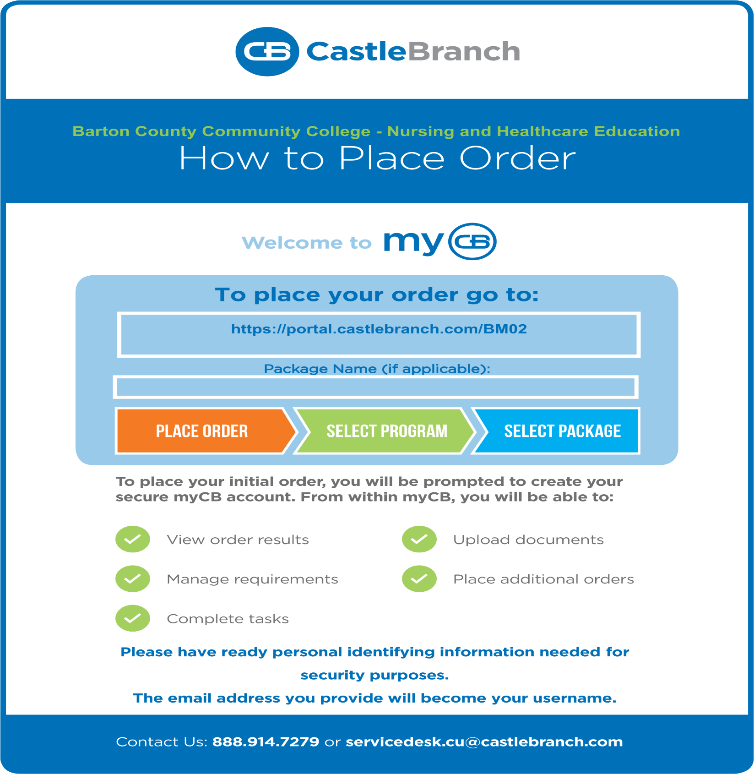

**ATTENTION Students**:

Barton Community College has partnered with CastleBranch to help you supply the requirements for your program including a background check, immunization record management and document tracking. This process needs to be **COMPLETED** before MLT classes with a cooperative lab begin. If you are ONLY doing phlebotomy this must be completed before class starts. To get started, have payment method ($92.00 cost) and personal identifying information ready. Carefully follow the instructions below:

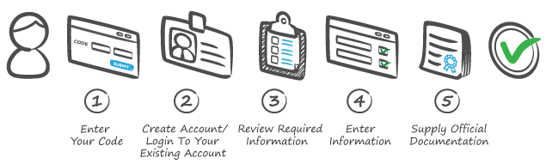

**To place your order go to:**

<https://portal.castlebranch.com/BM02>

|  |  |
| --- | --- |
| **Program:** | **Code:** |
| Phlebotomy | BM21 |
| MLT | BM22 |



To place your initial order, you will be prompted to create your secure myCB account. From within myCB, you will be able to:

Manage program requirements Complete tasks

Complete background check Upload, store and share documents

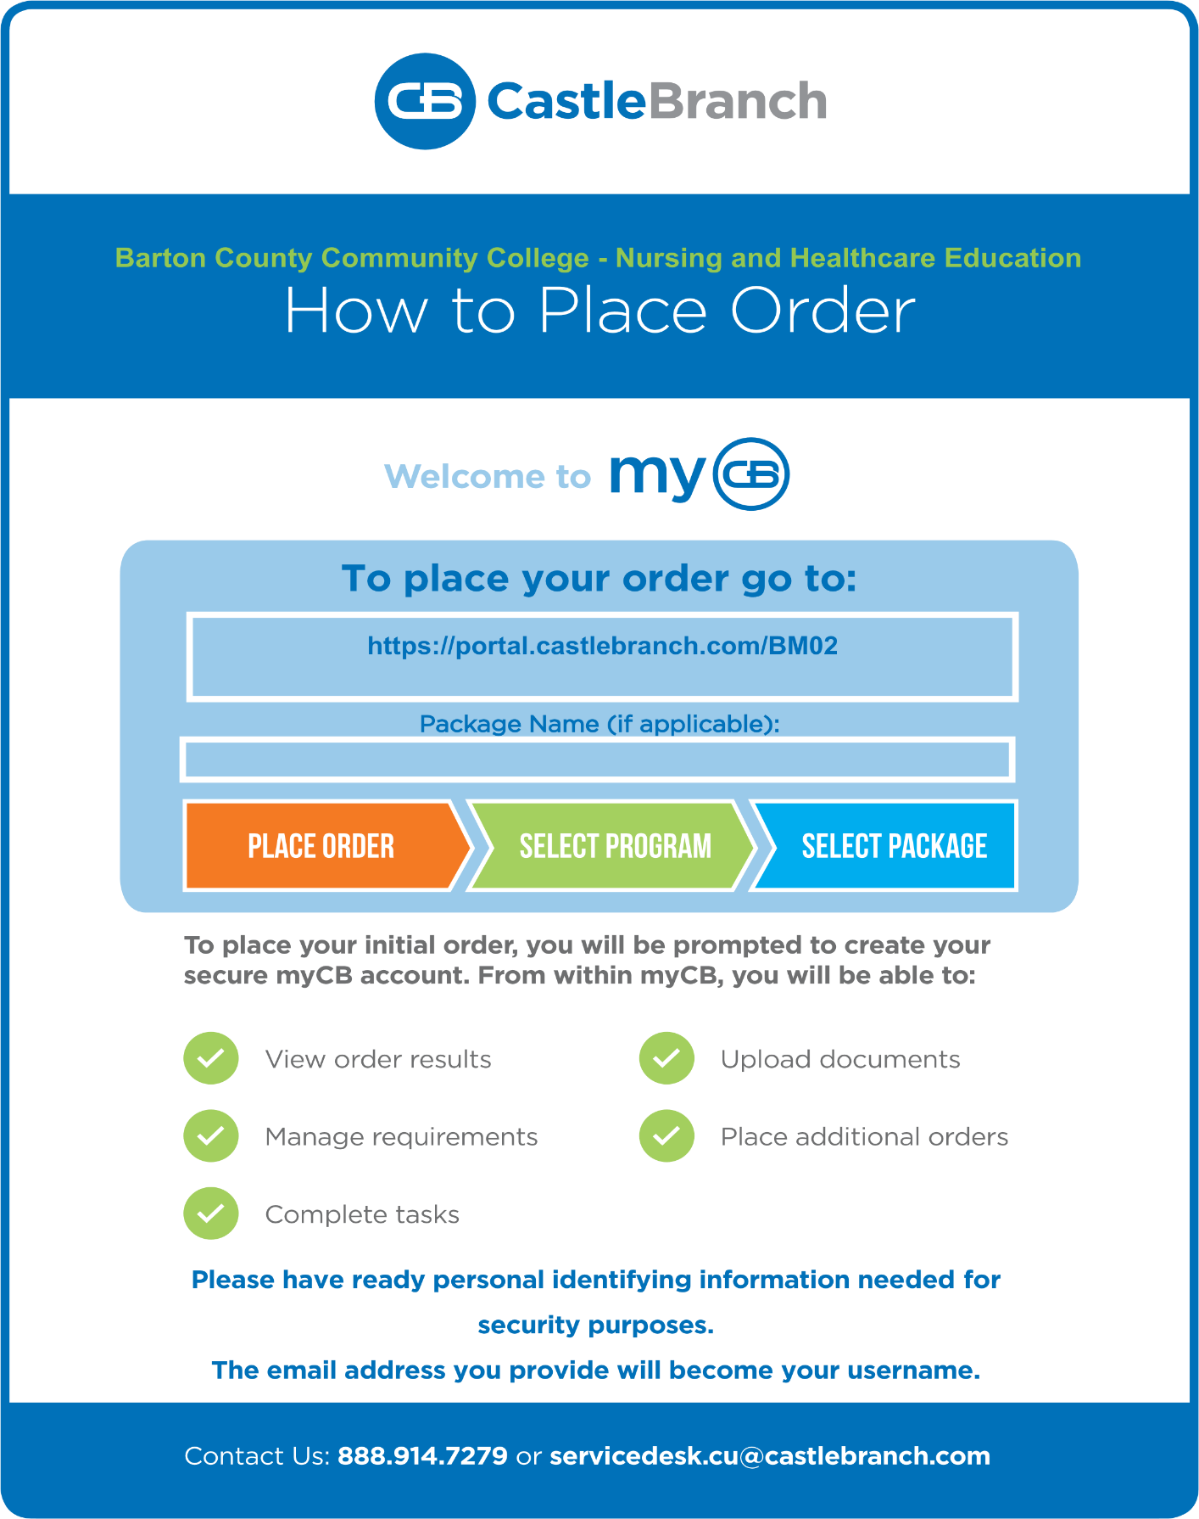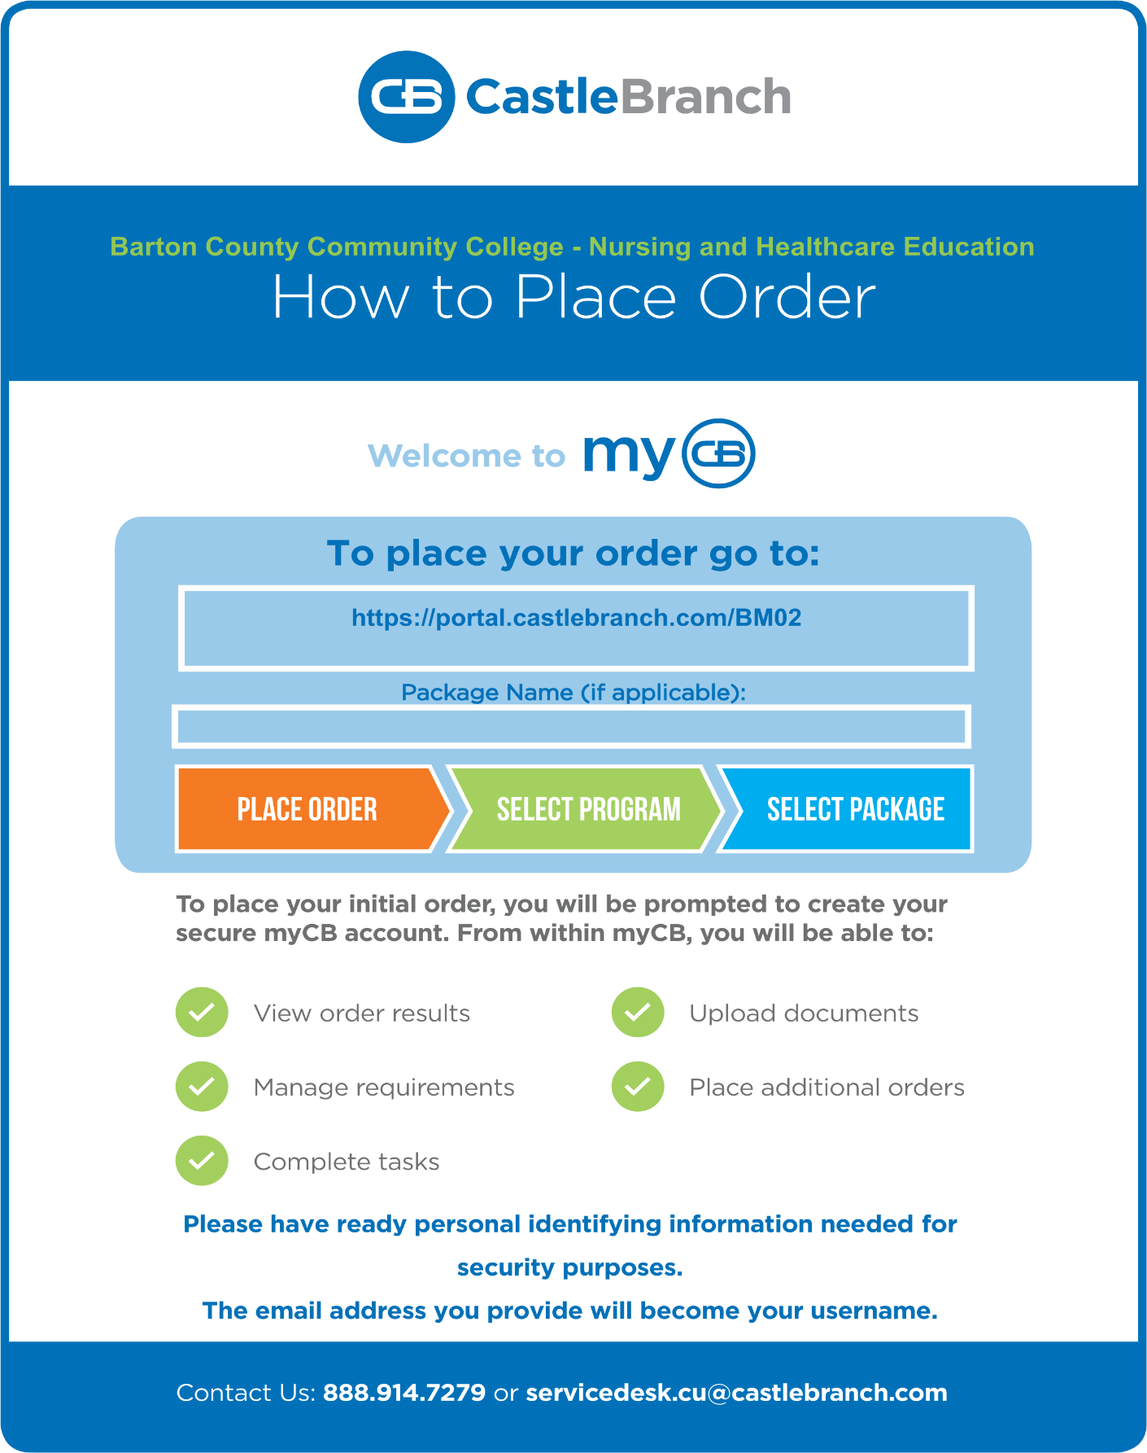



REQUIRED FORMS (1-4) TO BE UPLOADED TO YOUR MLT ACCOUNT:

**(1)**[**Essential Requirements**](http://docs.bartonccc.edu/degrees/career-programs/healthcare/medical-laboratory-technician/Essential%20Requirements.pdf)  **(2)**[**Student Physical Form**](http://docs.bartonccc.edu/degrees/career-programs/healthcare/medical-laboratory-technician/student-physical-form-2013.pdf)  **(3)**[**Immunization Form**](http://docs.bartonccc.edu/degrees/career-programs/healthcare/medical-laboratory-technician/immunization-form.pdf)  **(4)**[**Health record form**](http://docs.bartonccc.edu/degrees/career-programs/healthcare/medical-laboratory-technician/health-record.pdf)

**and (5) Proof of current health insurance.**

The email address you provide will become your username.   
This is a student-owned secure account and your access never expires.  
If you change degrees contact User Experience Team to move your account.