**CMA Textbooks**

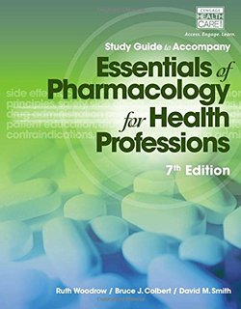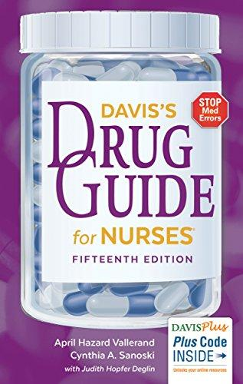

**\*\* You will need to have your books by the first day of class!**

**\*\* You will need to have your books by the first day of class!**

**\*\* You will need to have your books by the first day of class!**

**Davis’s Drug Guide for Nurses**

15th Edition

ISBN: 0803657056

Barton Bookstore Price: $50.00

Approx.

**Essentials of Pharmacology for Health Professions**

7th Edition

ISBN: 1285077881

Barton Bookstore Price: $130.00

Approx.

**Essentials of Pharmacology for Health Professions**

7th Edition

ISBN: 1285077881

Barton Bookstore Price: $130.00

Approx.

**Davis’s Drug Guide for Nurses**

15th Edition

ISBN: 0803657056

Barton Bookstore Price: $50.00

Approx.

**Essentials of Pharmacology for Health Professions**

7th Edition

ISBN: 1285077881

Barton Bookstore Price: $130.00

Approx.

**Davis’s Drug Guide for Nurses**

15th Edition

ISBN: 0803657056

Barton Bookstore Price: $50.00

Approx.

**CMA Textbooks**

**CMA Textbooks**